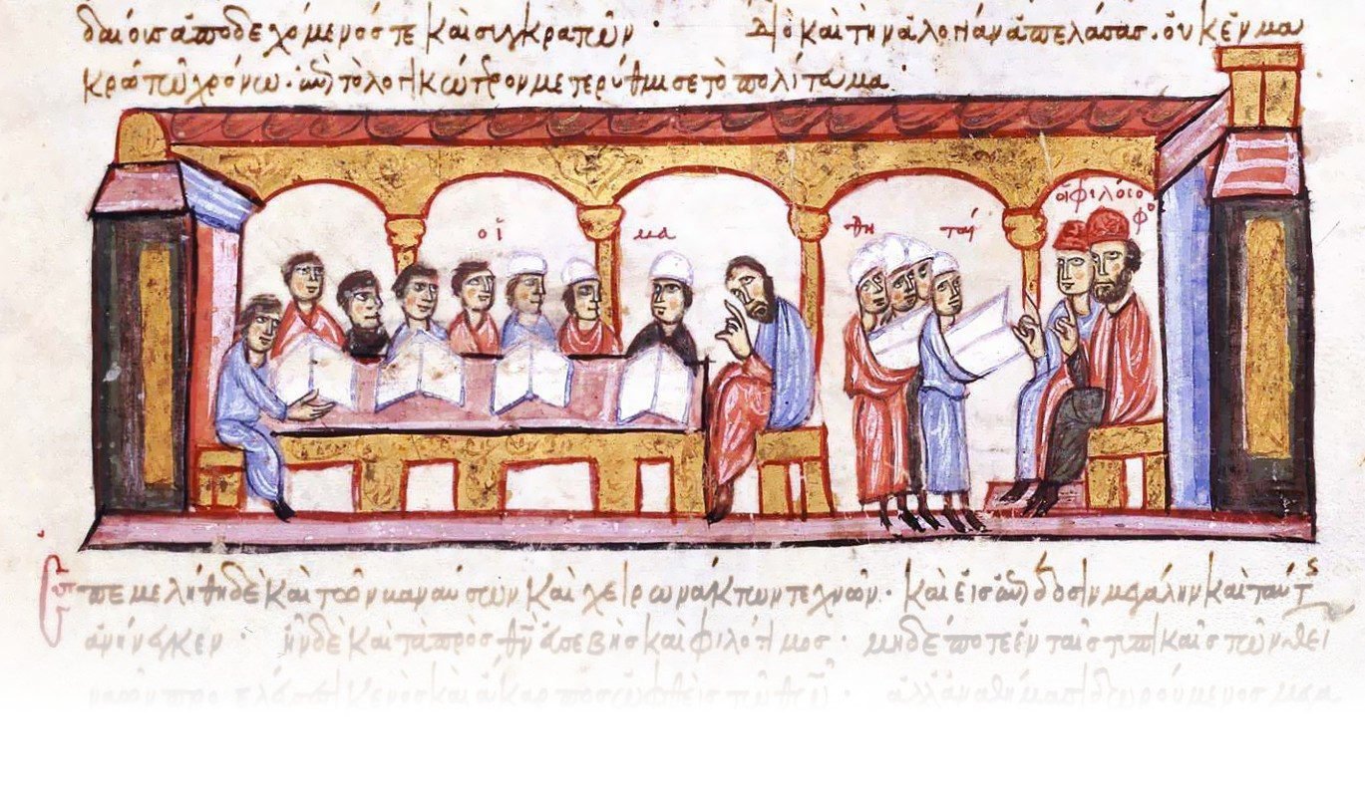
Colloquia Ceranea VII
8-10 May 2025

Application Form – Individual Submission

Please note:

The application form should be completed in English.
Papers should be presented in English. Other languages are acceptable too, provided that the speaker prepares an English handout (or multimedia presentation) outlining the main points of the talk.
The talk should last no longer than 20 minutes.
If you are requesting a reduced fee, require assistance during the conference or have a special dietary requirement (we will provide lunch during the conference for those attending in person), please write below.
Please sent the application by February 28, 2025 to the following e-mail address: colloquia.ceranea@uni.lodz.pl

First name:
Last name:
Academic title:
Institution:
Country:
E-mail:
Telephone number (not obligatory):
Title of paper:
Language of paper:
Multimedia presentation: yes/no
Form of participation: online/in person
Additional information:

ABSTRACT (no more than 300 words):

